ISLAMIC ART IN AL ANDALUS
As Islam spread from Arabia and its expansion was accomplished, Arabs adopted elements from Byzantine, Roman, Persian, etc., art styles, synthesizing them in a new one. Al-Quran prohibits any image of Creation, so no human being, animal, plant can be represented. That’s why architecture predominates in Islamic Art, being sculpture and painting only decorative.

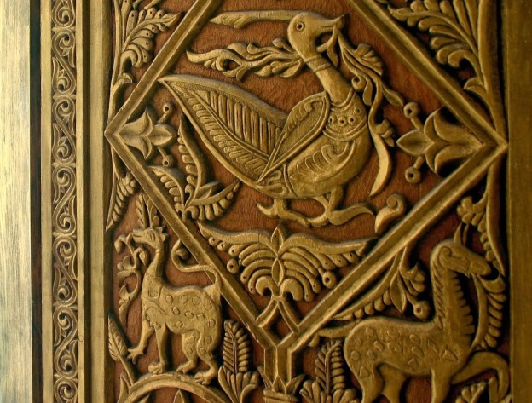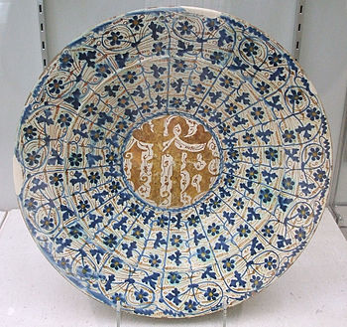
Pottery and leatherwork are also remarkable
ARCHITECTURE
The main types of Islamic buildings are mosques and palaces. Anyway, they built others like: hammam (public baths), fortresses, etc. They built them in poor construction materials (brick, wood, plaster, etc.), but their buildings transmit no sensation of poverty as they have abundant decorative elements (geometrical, vegetation, calligraphic motifs). The kind of arches they used were horseshoe arch, rounded arch, polylobed arch, etc. It is also significant the usage of the caliphal vault (a non-crossing ribbed vault)

Main Stages & buildings:
- Caliphate’s Architecture: The most remarkable remains of Al-Andalus architecture were built in the 10th So were the Mosque of Córdoba (VIII – X cent.) and the Palace of Medina al-Zahra (X cent.)
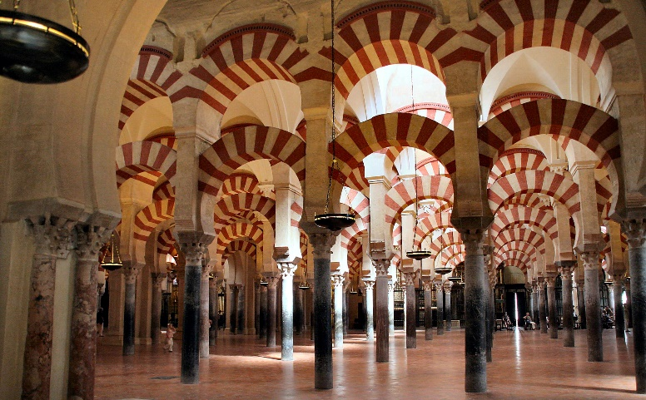
- Taifa Kingdoms’ Architecture: Every taifa prince wanted to embellish its capital, so they built lots of palaces and mosques in them. That is the case of the palace called Aljafería (Zaragoza). They also built fortresses and walls (in Málaga, Almería, Badajoz).

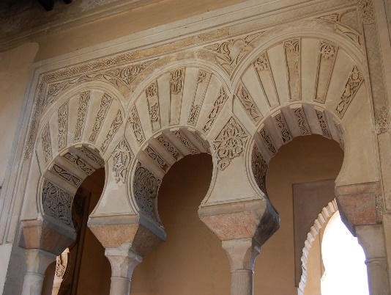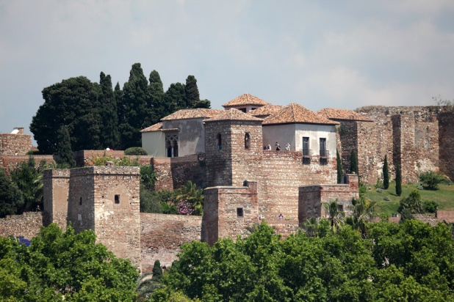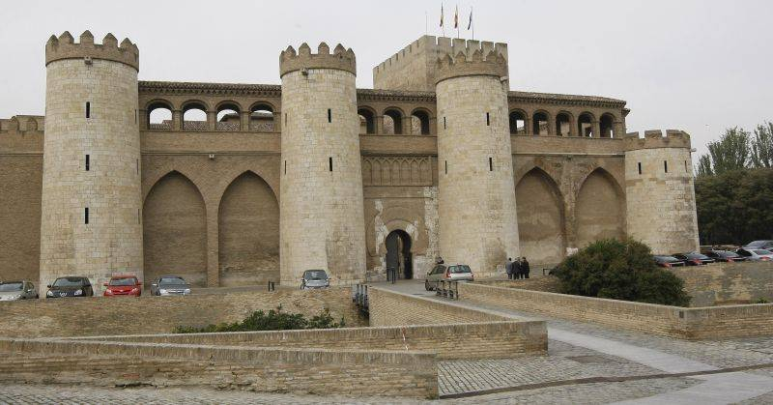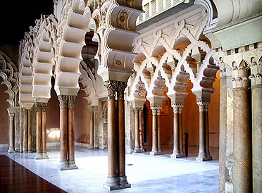

- Almohad Architecture: In this time are dated the Giralda (the minaret of the nowadays destroyed mosque of Sevilla) and Torre del Oro (a defensive tower in Sevilla, their capital city).

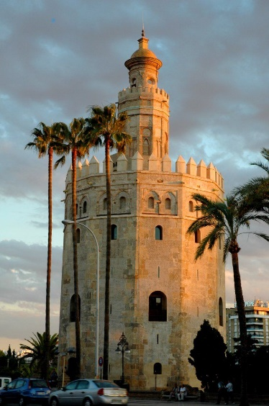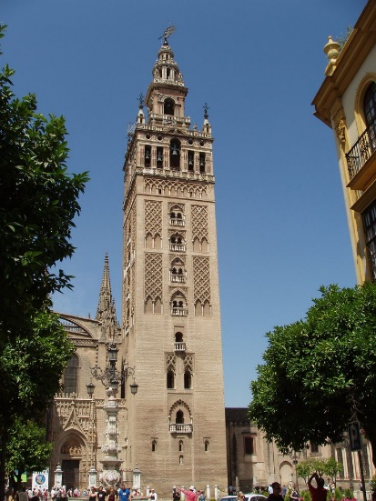
- Nazari Architecture (Granada): We will highlight the Alhambra, the most well - preserved palace from the medieval Islamic world.


