HISPANO-MUSLIM ART

Drag the names of the following architectural and decorative elements used in Hispano-Muslim art:
POINTED ARCH HORSESHOE ARCH SCALLOPED ARCH INTERTWINED ARCH OGEE ARCH
ARCHES
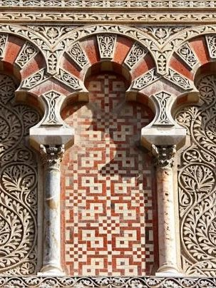
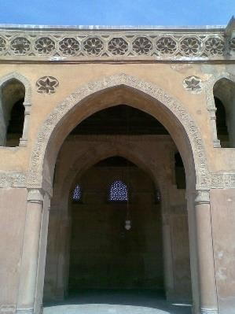
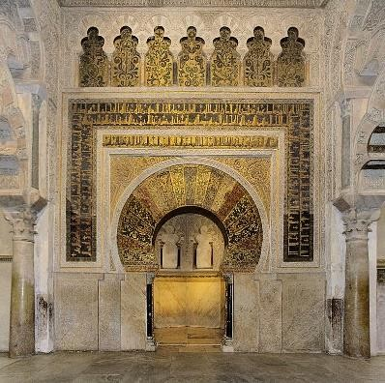
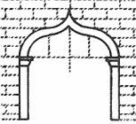

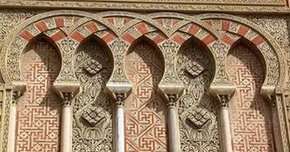

DECORATIVE ELEMENTS

STALACTITE PATTERN (MUQARNAS) GEOMETRIC PATTERN
ARABESQUE (PLANT MOTIF) CALLIGRAPHY

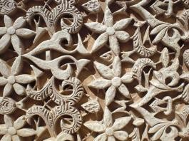
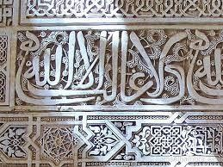
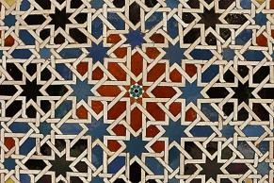
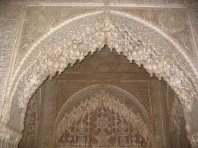

Drag the parts of the mosque to their corresponding place:
MIHRAB MINARET QIBLA COURTYARD HYPOSTYLE HALL ABLUTIONS FOUNTAIN

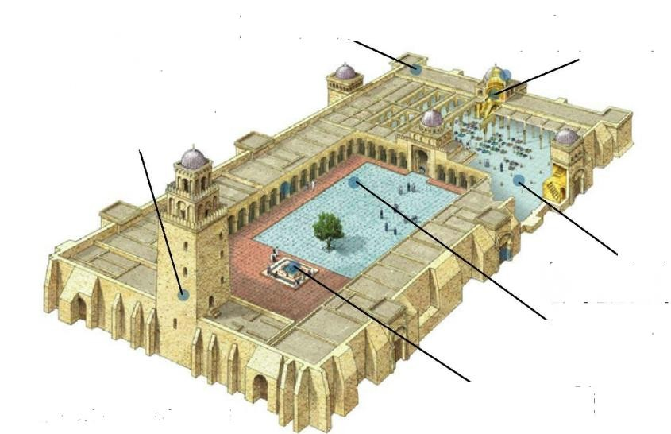

Drag the names of the main art works of Hispano-Muslim art:
CÓRDOBA’S MOSQUE ALCAZABA OF MÁLAGA ALJAFERÍA PALACE
GIRALDA OF SEVILLE ALHAMBRA OF GRANADA CRISTO DE LA LUZ’S MOSQUE

