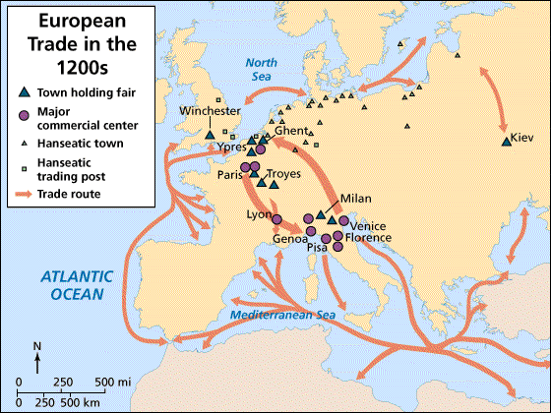

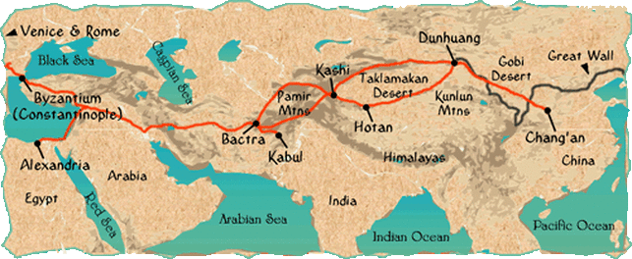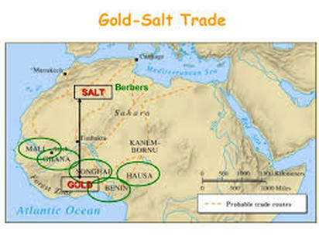

What impact did the Silk Road have in the Medieval Europe?

What was more significant than the exchange of goods in this trade routes?

What was a major downside of the networks of exchange?

What was the largest sea-based system of communication and exchange?

Trace the Silk Road, the Mediterranean route and the Gold – Salt route in the map

What European cities were famous for holding fairs?



