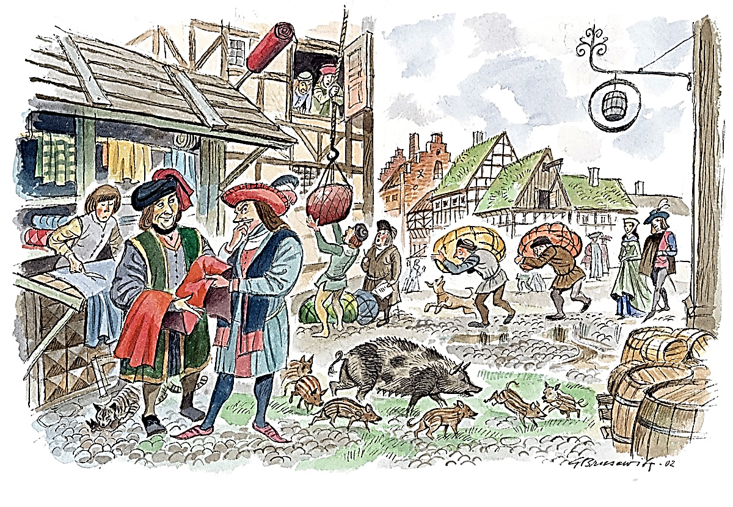
The Development of Medieval Guilds

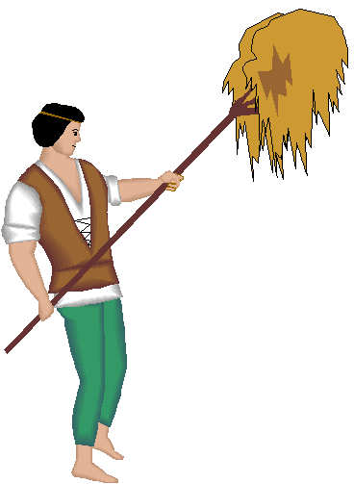
Starting in the 11th century, the population of Europe increased dramatically. This increase continued into the 14th century.
The introduction of the iron plow, a new harness that enabled
horses to be used for farming, and the three field system of crop
rotation allowed food production to keep pace with this increase.
This population increase created a rise in the demand for goods.

As trade increased, towns grew. The number of merchants, artisans, craftspeople, and workers living in towns increased. Beginning in the 12th century, many artisans and craftspeople joined together in what are called guilds, groups of people performing the same craft, usually in the same city, who joined together for their common good.
1.
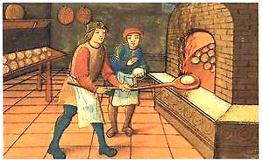

These guilds regulated the quality of goods produced, set prices, controlled the number of craftspeople, and also controlled where and to whom goods could be sold. Controlling the quality, the price, and the distribution worked out well for the guild members, as well as, their customers. People could count on goods of consistent quality at fair prices.
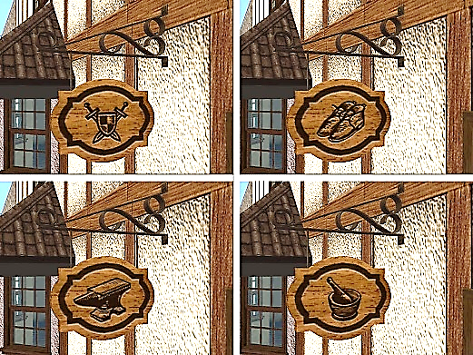
Guilds would regulate trade in medieval Europe for centuries.

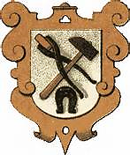
Because most medieval Europeans were illiterate,
guild shops would fashion a picture representing their business on their exterior sign instead of spelling out the name of the craft.
2.
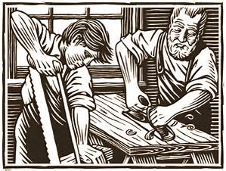
Workers in each guild shop were divided into three levels. At the bottom level
was the apprentice who usually worked
for room and board. He was in the first stage of learning the craft. He would usually perform the simplest tasks of the craft, learning more and receiving more responsibility as he gained experience.
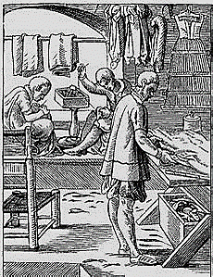
At the mid-level came the journeyman. He was paid for his skill in the craft but had not yet created a masterpiece.
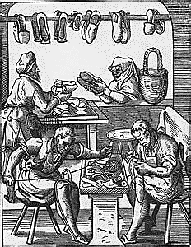
A masterpiece was a piece of work, related to his craft, fashioned by the journeyman, to be submitted to the guild for their approval before the journeyman could be considered a master of his craft.

At the highest level was the master,
or master craftsman, who after years
of learning the craft, had successfully created a masterpiece, and usually,
was either the owner of the craft shop
or in charge of it for the owner.

craft - a product or service
illiterate - not able to read or write
room and board - a place to live and eat
3.

Name______________________________________________________Date_________________Period____

The Development of Medieval Guilds - Assessment
Directions: Circle the letter of the correct answer.

1. What made it possible for food production to keep pace with the increase in population between the 11th and the 14th centuries ?

a. the three field system of crop rotation
b. iron plow
c. a new harness for plow horses
d. all of the above

2. Between the 11th and 14th centuries, trade increased. What was a result of this ?

a. the number of merchants, craftspeople, and workers living in towns increased.
b. many artisans and craftspeople joined together in guilds.
c. towns grew
d. all of the above

3. What is a guild ?
a. a system designed to increase the number of artisans and craftspeople living
in the towns, cities, and farms.

b. an organization designed to introduce agricultural innovations to medieval Europe.

c. a group of people performing the same craft, usually in the same city, who joined together for their common good.

d. all of the above

4. Why did guild members have a picture representing their business on their exterior sign instead of spelling out the name of the business ?

a. because the townspeople couldn't see them easily
b. because most of the townspeople were illiterate.
c. because the artisans and craftspeople were performing similar services.
d. all of the above

5. Rank the members of the guild by their levels:

Journeyman _____ a. highest
Apprentice _____ b. middle
Master_____ c. lowest

Name___________KEY________________________________Date_____________Period___

The Development of Medieval Guilds - Assessment
Directions: Circle the letter of the correct answer.

1. What made it possible for food production to keep pace with the increase in population between the 11th and the 14th centuries ?

a. the three field system of crop rotation
b. iron plow
c. a new harness for plow horses
d. all of the above

2. Between the 11th and 14th centuries, trade increased. What was a result of this ?

a. the number of merchants, craftspeople, and workers living in towns increased.
b. many artisans and craftspeople joined together in guilds.
c. towns grew
d. all of the above

3. What is a guild ?
a. a system designed to increase the number of artisans and craftspeople living
in the towns, cities, and farms.

b. an organization designed to introduce agricultural innovations to medieval Europe.

c. a group of people performing the same craft, usually in the same city, who joined together for their common good.

d. all of the above

4. Why did guild members have a picture representing their business on their exterior sign instead of spelling out the name of the business ?

a. because the townspeople couldn't see them easily.
b. because most of the townspeople were illiterate.
c. because the artisans and craftspeople were performing similar services.
d. all of the above

5. Rank the members of the guild by their levels:

Journeyman b. a. highest
Apprentice c. b. middle
Master a. c. lowest

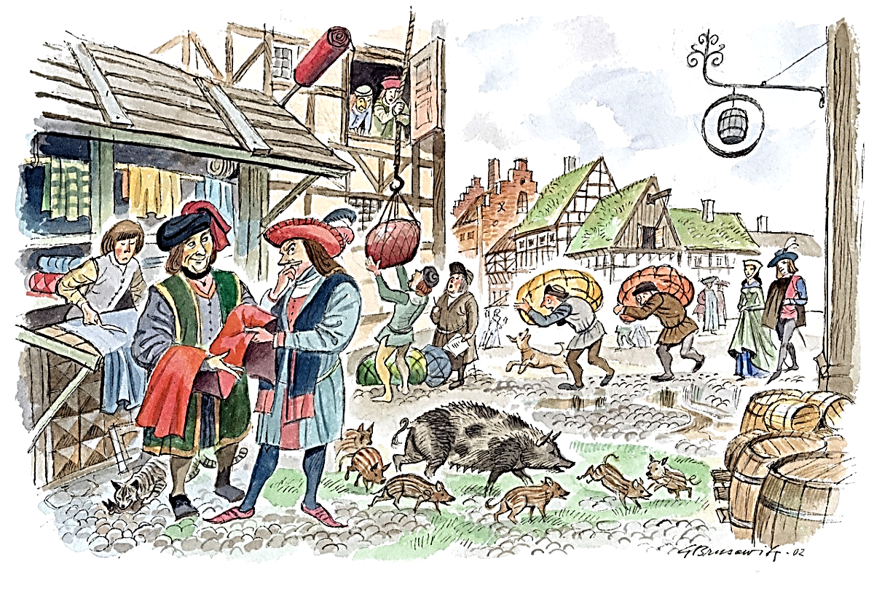
The Development of Medieval Guilds

Starting in the 11th century, the population of Europe increased dramatically. This increase continued into the 14th century.
The introduction of the iron plow, a new harness that enabled
horses to be used for farming, and the three field system of crop
rotation allowed food production to keep pace with this increase.
This population increase created a rise in the demand for goods.

As trade increased, towns grew. The number of merchants, artisans, craftspeople, and workers living in towns increased. Beginning in
the 12th century, many artisans and craftspeople joined together
in what are called guilds, groups of people performing the same craft, usually in the same city, who joined together for their common good.
1.

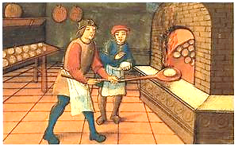
These guilds regulated the quality of goods produced, set prices, controlled the number of craftspeople, and also controlled where and to whom goods could be sold. Controlling the quality, the price, and the distribution worked out well for the guild members, as well as, their customers. People could count on goods of consistent quality at fair prices.
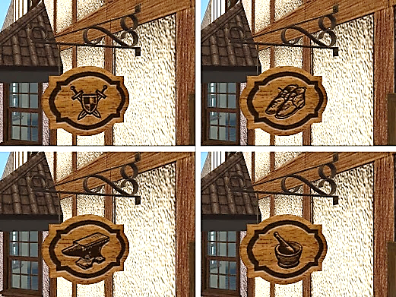
Guilds would regulate trade in medieval Europe for centuries.

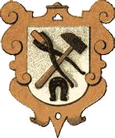
Because most medieval Europeans were illiterate,
guild members would fashion a picture representing their business on their exterior sign instead of spelling out the name of the craft.
2.
Workers in each guild shop were divided into three levels. At the bottom level
was the apprentice who usually worked for room and board. He was in the first stage of learning the craft. He would usually perform the simplest tasks of the craft, learning more and receiving more responsibility as he gained experience.
At the mid-level came the journeyman. He was paid for his skill in the craft but had not yet created a masterpiece.
A masterpiece was a piece of work, related to his craft, fashioned by the journeyman, to be submitted to the guild for their approval before the journeyman could be considered a master of his craft.

At the highest level was the master,
or master craftsman, who after years
of learning the craft, had successfully created a masterpiece, and usually,
was either the owner of the craft
shop or in charge of it for the owner.
craft - a product or service
illiterate - not able to read or write
room and board - a place to live and eat

3.

6-8. The Development of Medieval Guilds - Short Answer Assessment
Directions: Complete the following task correctly, using complete sentences and support from text.
(1pt. Correct Answer) (1pt. Complete Sentences) (1pt. Support from Text)
Explain the concept of a masterpiece:

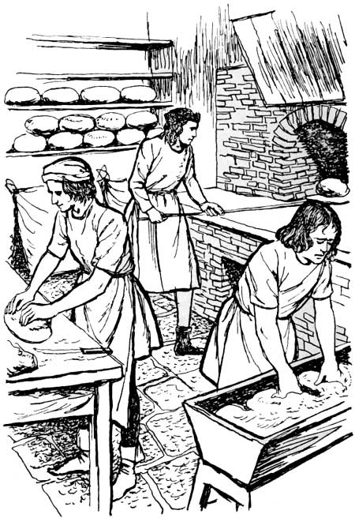
______________________________________________________________________________________________________________________________________________________________________________________________________________________________________________________________________________________________________________________________________________________________________________________________________________________________________________________________________________________________________
_______________________________________
_______________________________________
_______________________________________
_______________________________________

6-8. The Development of Medieval Guilds - KEY
Directions: Complete the following task correctly, using complete sentences and support from text.
(1pt. Correct Answer) (1pt. Complete Sentences) (1pt. Support from Text)
Explain the concept of a masterpiece:

Information to complete the above task is located in these two paragraphs.

"At the mid-level came the journeyman. He was paid for his skill in the
craft but had not yet created a masterpiece. A masterpiece was a piece, fashioned by the journeyman, to be submitted to the guild for their approval before the journeyman could be considered a master of his craft.

At the highest level was the master, who after years of learning the craft, had successfully created a masterpiece and usually was either the owner of the craft shop or in charge of it for the owner."

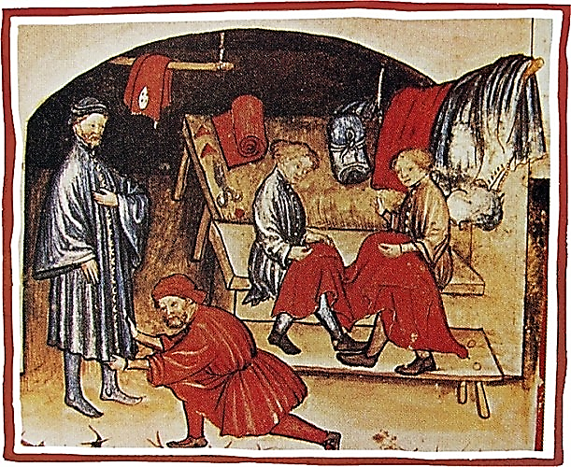
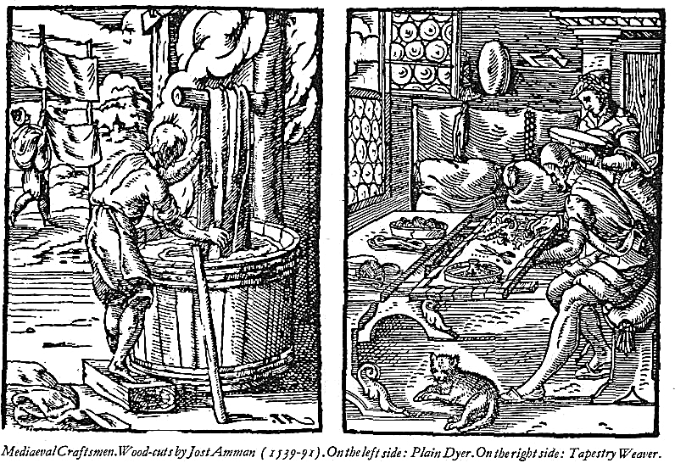

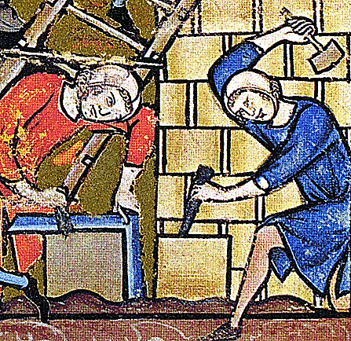

Medieval Tailors Medieval Stone Masons

Medieval Cobblers
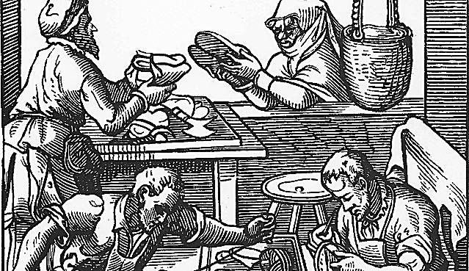
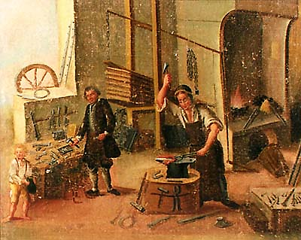

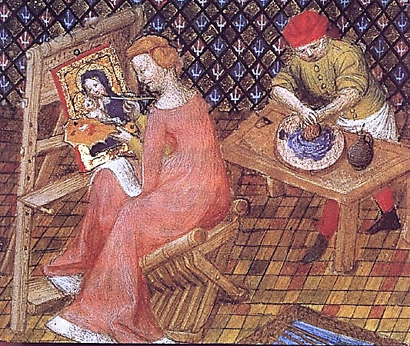
Medieval
Blacksmiths Medieval Artisans

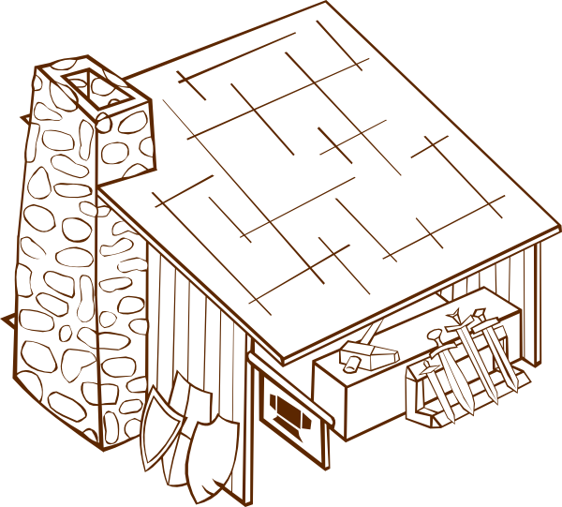
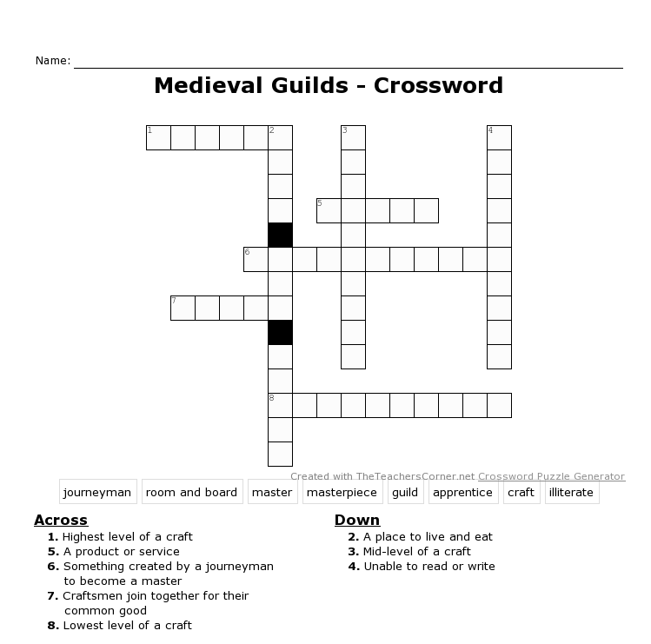

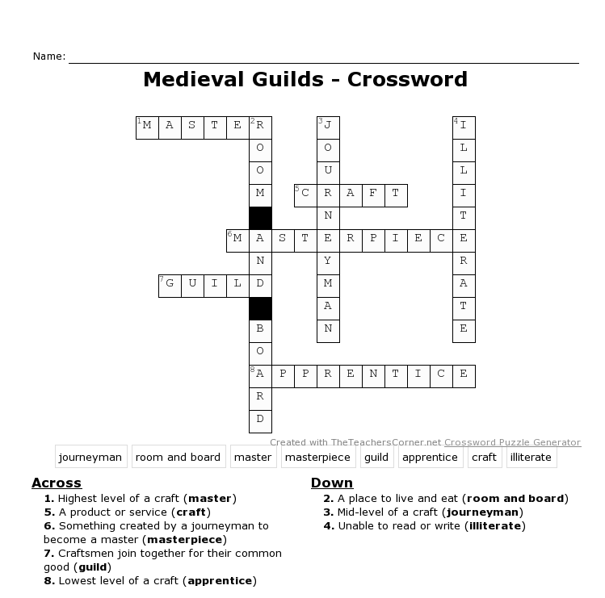
KEY

Short Answer Rubric (Teacher)
Students can easily score each other's answers by looking:
First: to see if the answer includes complete sentences.
Second: to see if the answer is correct.
Third: to see if there is support from the text.
This works best if done as a whole-class activity.
You may want to give these tasks separately to avoid confusion.
Each time they find one of those three present, allow one point.
Medieval Guilds
Common Core Standards Addressed
CCSS.ELA-LITERACY.RH.6-8.1 CCSS.ELA-LITERACY.WHST.6-8.4 CCSS.ELA-LITERACY.W.7.4 CCSS.ELA-LITERACY.RH.6-8.10 CCSS.ELA-LITERACY.WHST.6-8.9 CCSS.ELA-LITERACY.W.7.9
CCSS.ELA-LITERACY.WHST.6-8.10 CCSS.ELA-LITERACY.W.8.4

ccss.ela-literacy.w.5.4 ccss.ela-literacy.whst.9-10.1d CCSS.ELA-LITERACY.W.8.9
ccss.ela-literacy.w.5.9 ccss.ela-literacy.whst.9-10.4 CCSS.ELA-LITERACY.W.9-10.4
ccss.ela-literacy.w.6.4 ccss.ela-literacy.whst.9-10.9 CCSS.ELA-LITERACY.W.9-10.9
ccss.ela-literacy.w.6.9

ccss.ela-literacy.ccra.w.4 CCSS.ELA-LITERACY.RI.5.1
ccss.ela-literacy.ccra.w.9 CCSS.ELA-LITERACY.RI.6.1
CCSS.ELA-LITERACY.CCRA.W.10 CCSS.ELA-LITERACY.RI.8.1
CCSS.ELA-Literacy.RI.9-10.1

California State History-Social Science Content Standard Addressed: 7.6.3
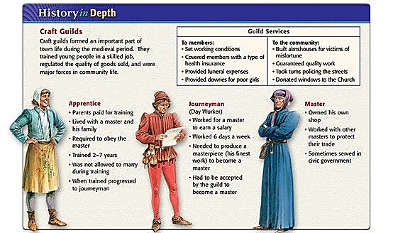
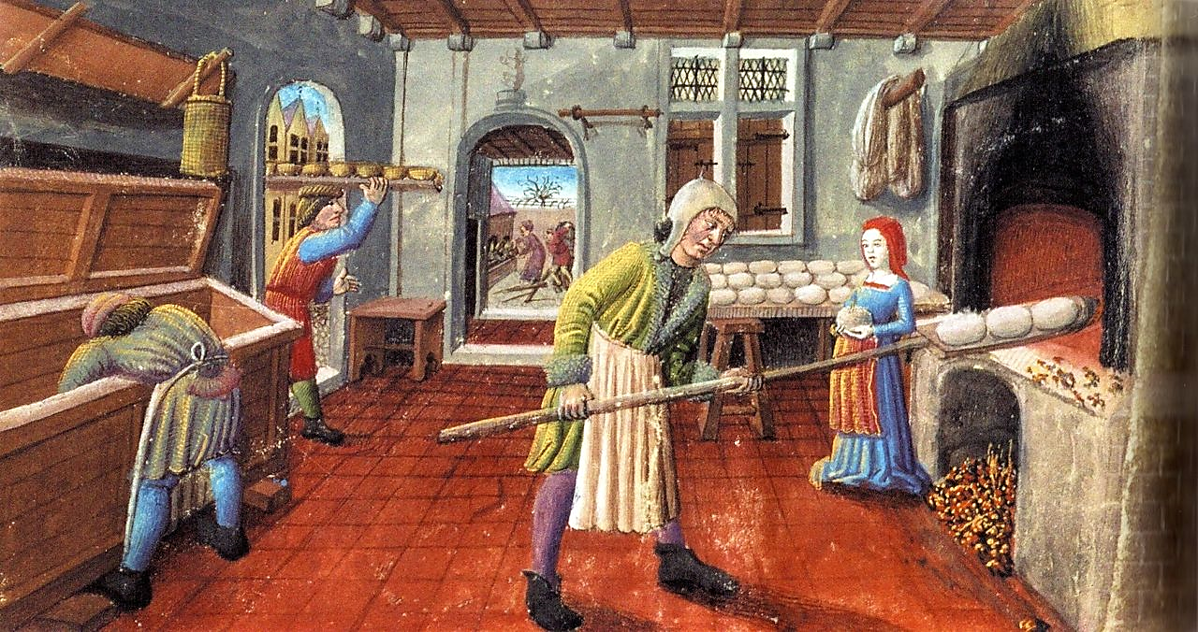
Medieval Bakers

Student's Short Answer Rubric
Students can easily score each other's answers by looking:
First: to see if the answer includes complete sentences.
Second: to see if the answer is correct.
Third: to see if there is support from the text.
You may want to perform these tasks separately to avoid confusion.
Each time you find one of those three present, allow one point.

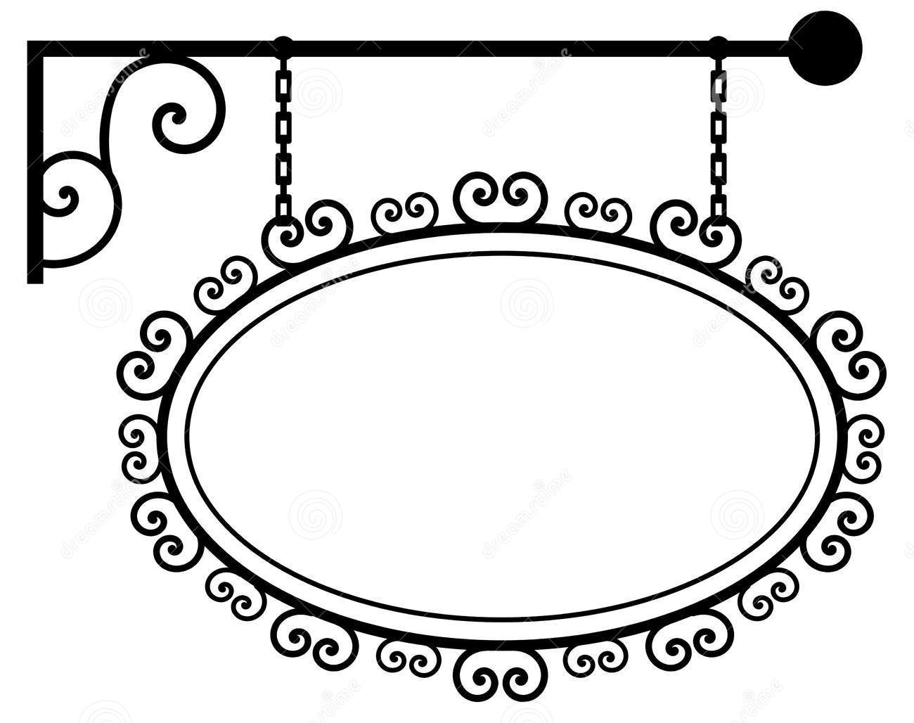

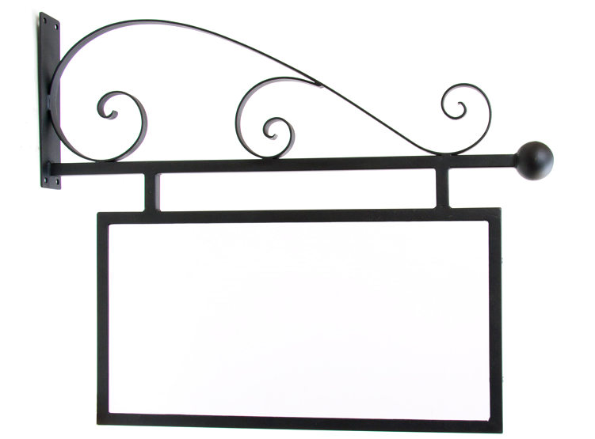





Name_________________________________________________Date_____________Period___
3-2-1
__________________________________________
Three things I learned:
- _______________________________________________________________________________
_______________________________________________________________________________
- _______________________________________________________________________________
_______________________________________________________________________________
- _______________________________________________________________________________
_______________________________________________________________________________
Two things I'd like to know more about:
- _______________________________________________________________________________
_______________________________________________________________________________
- _______________________________________________________________________________
_______________________________________________________________________________
One question I still have:
- _______________________________________________________________________________
_______________________________________________________________________________

"Support from Text" is really not as difficult as you might think. It's simply recording part of the text that confirms your response to a question.

To answer the short-answer questions posed in this lesson,

it's easy to include "support" in your answer. The following examples can make the job simpler:

In paragraph 4 it states, "..................(quote) .............. "

In paragraph 2 it states that ............. (paraphrase) .............

More specifically:

In the article "----------------," page 2, paragraph 4, it states, " ............. (quote) ............. "

In the article "--------------," page 3, paragraph 2, it states that ........... (paraphrase) .........

The use of the word "that" changes an answer that uses a quote to one
that uses a paraphrase.

Other sources are sometimes included in a lesson. These include books, magazines, internet sources, videos, etc. The trick is to identify the source
of the text you are using for support and then record it or paraphrase.

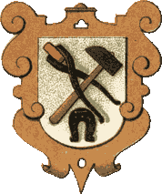
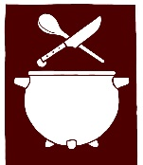
Historical Examination Form for:
Medieval Guilds

Year(s) __________________________________

Notable Organization(s): ________________________________________________ ____________________________________________________________________
____________________________________________________________________

Notable Levels: ______________________________________________________ ____________________________________________________________________
____________________________________________________________________
____________________________________________________________________
____________________________________________________________________

Masterpiece: _________________________________________________________ ________________________________________________________________________________________________________________________________________

Examiner Observations: ________________________________________________ ________________________________________________________________________________________________________________________________________
____________________________________________________________________

Examiner's Name: ____________________________________________________

International Historical Society

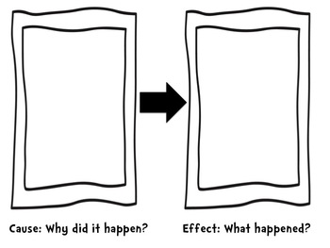
Name______________________________________Date_____________Period___
Four Takeaways
Medieval Guilds
Journeyman
Apprentice
Master
Guilds

Medieval Guilds - Activity

Medieval Guilds consisted primarily of two types:

1. Merchant Guilds: made up of traders who bought and sold goods
in the form of raw materials and/or finished goods.

2. Craft Guilds: made up of artisans who created goods or services
for daily use.

It is said that guilds were made up of skilled people who joined together for their common good. So what was that common good ?

Generally speaking, both Merchant and Craft guilds shared most practices
in common. They regulated the price, the quality, and the volume of the products that could be sold. They offered protection for traveling guild members and their possessions against highwaymen. They agreed on charters with the noble, who owned the land on which the town was located, to collect taxes on goods or services to pay that lord. They would donate some of their goods or services to the local church, and they supported and cared for guild members and their families. Some guild masters would serve as town officials.

With that in mind, any shop that applied to a guild would be well aware that there were rules to follow, standards to which it must adhere, and financial commitments that it would be required to make. However, these practices ensured that each shop could thrive within its community without worry of unfair competition. The general public also benefited from these arrangements because they could rely on good quality at reasonable prices.

Merchant Guild Shops could sell a wide range of goods, whereas,
Craft Guild Shops usually produced a single product, a line of
associated products, or a service.

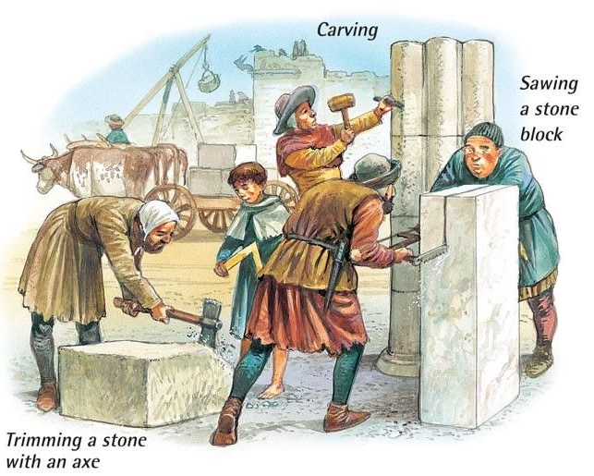
Some Craft Guilds:

Masons: Masons did mostly brick and stone construction, usually churches, castles, and cathedrals. Their guild was a universal guild. Because they traveled from town to town where the work was necessary, having a
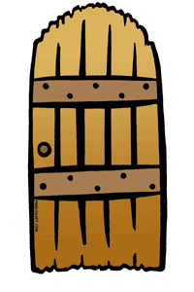
guild located in one city was not practical.
Carpenters: Carpenters worked with wood to make windows, doors, wooden beams, fences, and furniture. In addition to woodworking skills, it was necessary for a carpenter to understand mathematics.
Cobblers: Cobblers made and repaired various kinds of shoes, mostly
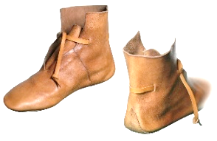
for commoners. Nobles usually had a special cobbler to make their higher fashion shoes, as well as, boots for knights. Cobblers had to be skilled in the use of leather and sewing (stitching).

Bakers: Bakers primarily needed to know the ingredients and exact quantities that were necessary to make bread, as well as, the time and temperature

it took to bake it in a stone oven, as this was their main product. They would have knowledge of extra additives such as almonds, honey, garlic, and to a lesser degree, cinnamon, to vary the taste
of the finished product.

Cloth Makers: Cloth makers worked primarily with wool, but cotton,
linen and leather were also used. A medieval cloth maker would need
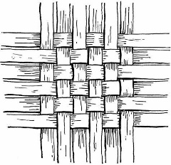
working knowledge of the process of converting wool into yarn, but the primary skill would require weaving wool. Weaving involved the use of two sources of yarn and intertwining them
in a perpendicular pattern to create a garment or a blanket etc.

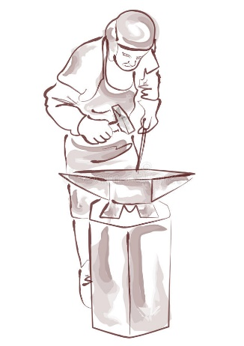
Metalsmiths: Called blacksmiths, these metal workers crafted metal into a variety of products ... from weapons, shields, and armor to farming tools, horseshoes, and nails. They would require a working knowledge of smelting, tempering, and hardening in order to make a quality piece strong and durable. Finally they would be required to master the art of shaping the piece with hammers (striking) and files.


Candle Makers: Candle Makers (chandlers) fashioned candles from tallow and bees wax, using flax, hemp, or cotton for wicks. Tallow candles gave off an unpleasant odor when burned, so they were
used exclusively by peasants. Bees wax candles were used by the nobility because they could afford them. Chandlers would heat and
fashion both types into a mold, add a wick, and let them dry. This simple process meant that peasants could make their own candles, so chandlers
did not make a lot of money making tallow candles. Their income came primarily from the manufacture of the more expensive bees wax candles

that smelled better. Chandlers would also augment their income by keeping bees, as well as, manufacturing soap which included various combinations of ash, lime, oils, beer, flour, and animal fat.

Merchant Guilds: In addition to the regulations and benefits they shared with craft guilds, merchant guilds regulated weights and measures and monitored business practices among the town's merchants.

Merchants : Merchants would buy a variety of goods from local or long-distance sources and sell raw materials at wholesale prices to craft guilds or finished goods at retail to the public. A shop owner would need a working knowledge of mathematics, as well as, marketing and accounting skills.

Medieval Guilds Activity - Vocabulary

raw materials: the basic materials with which a finished product is made
finished goods: goods that are ready to be consumed (used) by the public

artisans: artists and craft persons

blacksmith: "black" refers to the color of iron when it is heated.
"smith" refers to the striking required to shape the metal.

smelting: the process of removing metal from its ore by melting it in a charcoal-fueled fire

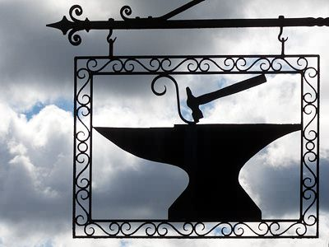
tempering and hardening: the process of alternating heating and cooling while shaping (striking) metal

tallow: animal fat
flax: a fibrous food plant used to make wicks and linen
hemp: a fibrous plant used to make rope and wicks
augment: increase, add to
wholesale: selling goods to other people who will use them to produce finished products and sell them at retail prices

retail: the sale of goods for consumption (use) rather than for resale
marketing: the activities involved in buying an item at wholesale, displaying it, and bringing about its sale at retail

accounting: keeping track of purchases, sales, and expenses

Medieval Guild Application

To complete your Craft Guild Application, you must demonstrate your knowledge of both the requirements and benefits of our Guild, as well as, the skills you must possess to become a member shoppe. Include a proposed exterior sign design and masterpiece.

The Guild: ____________________________________________________________

Name of Applicant: _____________________________________________________

Proposed Name of Shoppe: ______________________________________________

Acknowledgement of Guild Requirements and Benefits

List Requirements:

List Benefits:

List Skills Required of the Shoppe:

Shoppe Masterpiece Illustration:


Shoppe Sign Illustration:

The Three-Field System of Crop Rotation

To meet the need for more food and to reduce the possibility of starvation in medieval Europe, the three-field system of crop rotation was also developed.
In this system, farmers changed the use of fields over time. Each of two fields would be planted with different crops, while a third field would lie fallow.*
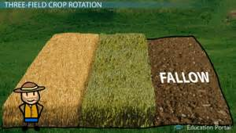
Each time crops are planted in a field, they use much of the nutrients* that
the soil can provide.

Leaving a field unplanted for a year allowed the soil to replenish these nutrients naturally, making it ready to be planted the next year. These three fields would be rotated each year
so a different field would remain unplanted. If one of the two crops failed, the other would serve as a backup. And, a new field would be ready to plant the next year. This system dramatically reduced medieval Europeans' risk of starvation
due to crop failure and increased Europe’s supply of food.
* lie fallow: remain unplanted nutrients: minerals that are essential for growing
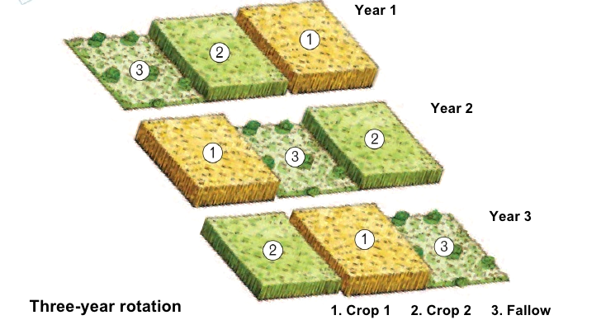

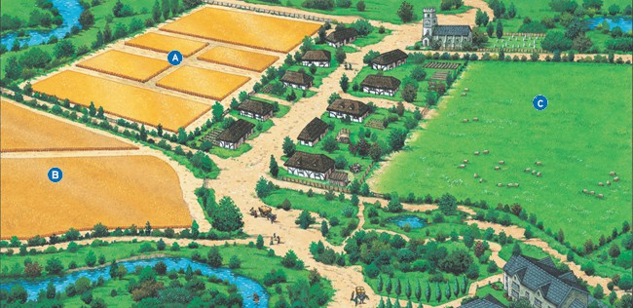
Fallow (unplanted)
Wheat

Barley*

*Barley: makes a good cereal grain, bread, animal feed, and a fermentable material for distilled beverages, mostly beer.

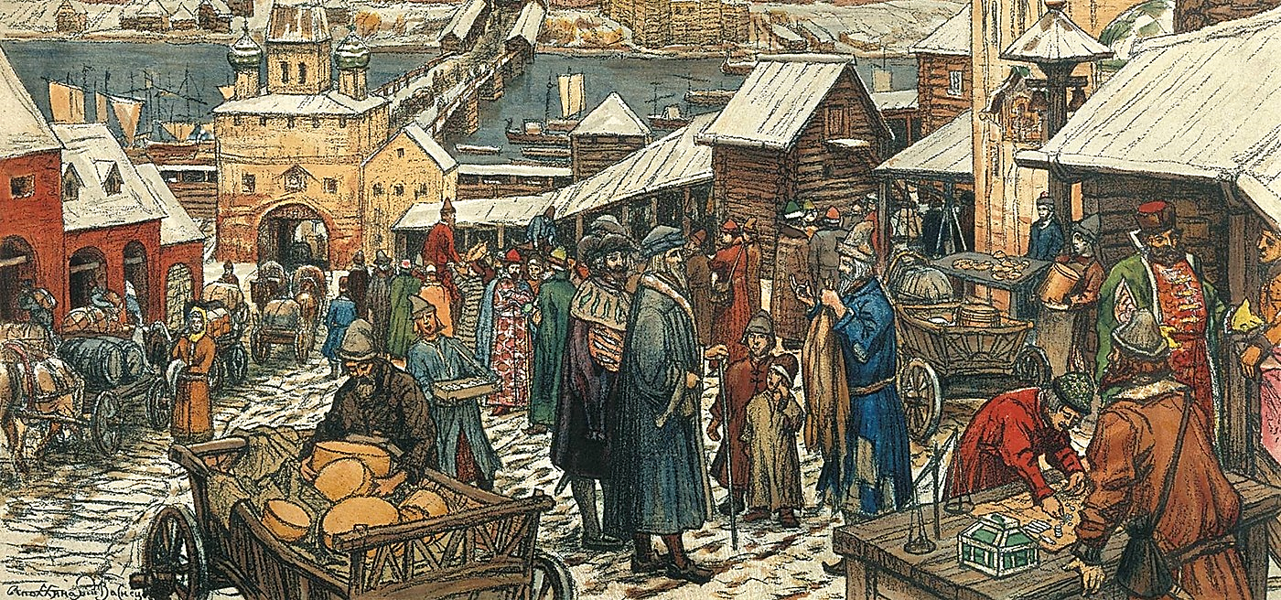
Medieval Market
Medieval Guilds
