FEUDAL SOCIETY
The feudal society was organized into estates which were social groups based on their origins. This type of society was very rigid and hierarchical. The only way to pass from one estate to other was to become a member of the clergy.

There were two estates:
- Privileged estates were the nobility and the clergy. This estate was a minority which had different laws from the rest of the society. They also did not pay taxes.

- The non – privileged were the rest of the society. It was mainly made up of peasants but also traders and craftsmen were included in this estate. They paid taxes and maintained the privileged estates.

Estates in the medieval society were the nobility, the clergy and the peasants.
NOBILITY
Nobles were dedicated to fight in wars and to defend the kingdoms. There were two types of nobles:
- The higher nobility was made up of dukes, marquises, and counts. They were vassals of the king but also, they were lords of other vassals of a minor rank. They used to live in castles or palaces, collected taxes and administrated justice in their fiefs.
- The lower nobility Knights were the lower nobility group. They had weapons and a horse but were not rich as they depended on other nobles being their vassals.

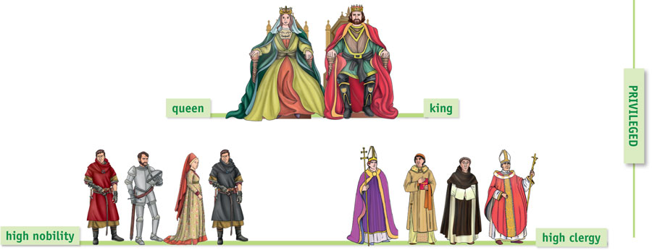
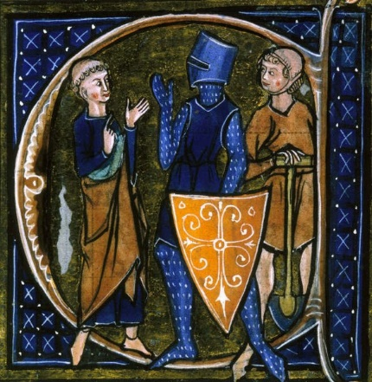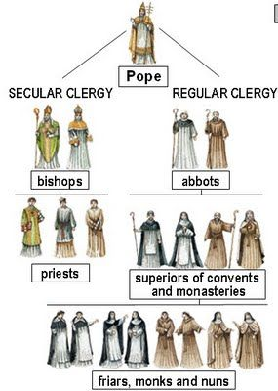
CLERGY
It was made up of members of the church and they were divided in two types:
- The secular clergy was composed by priests who depended on a bishop.
- The regular clergy was formed by members of religious orders, and they lived in monasteries and convents.
There were two main groups in the clergy according to their position:
- Higher clergy formed by bishops, abbots and cardinals who belonged to noble families and also could be feudal lords.
- Lower clergy were the rest of the clergy: priests, monks, friars and nuns.

PEASANTS
They were the 90% of medieval society. Peasants paid taxes to:
- The noble they were vassals of.
- The Tithe to the church consisting in one tenth of the harvest.
Peasants could be classified in two groups:
- Free peasants owned lands and could leave the fief without the permission of the lord. They had to work in the demesne and pay taxes to the lord and the church.
- Serfs could not leave the fief and required the permission of the lord for certain activities such as to get married. They also paid taxes and worked the lord´s land as well as performed domestic services in the castle – cleaning, cooking etc.

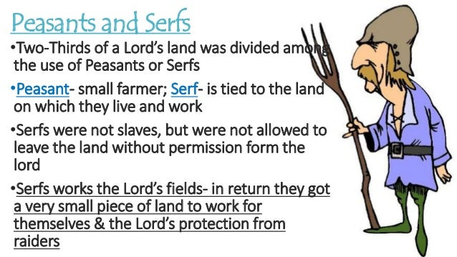

FEUDALISM
The political, economic and social system that predominated in Western Europe between the 10th and the 13th centuries is known as feudalism. When the Carolingian Empire collapsed, the kings used armed men to fight against the foreign invaders (Muslims, Vikings, and Magyars) who attacked Europe in the 9th century. In exchange for their help, the kings gave them land.
Feudalism was a system in which a free person was dependent on another and became his vassal.

The commitment between the vassal and the lord was sealed with an act of homage.
- The vassal swore loyalty to his lord and swore to provide him troops for fighting and advice.

- The lord swore to protect his vassal and provide him with the resources he needed to make a living: a piece of land called fief.

Gradually, a pyramidal system was created under which free people were linked by vassalage to others of a higher social rank. For example a noble could be a vassal of a king and, at the same time, he could also be the lord of a noble of a lower rank. The bishops and the abbots also received fiefs. At the top of the feudal pyramid was the monarch. Although , he was a vassal to nobody, he lost some of the power to the feudal lords. The economy was based on agriculture and livestock. It was organized in the fiefs or manors.
Fiefs were rural states made up of arable lands, pastures, and forests. The products obtained from forests were fruit, timber, medicinal plants, mushrooms, or honey.
Fiefs were self- sufficient as they produced almost all what their inhabitants consumed without buying many products from outside the manor.

On the other hand, the feudal lords exercised their authority over the peasants who worked on the feudal state. So, dependent relationships were created between the lower social classes and the nobles.

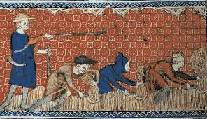
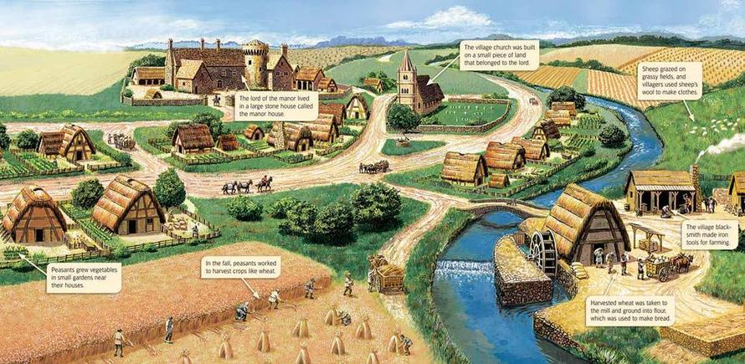
FEUDAL ECONOMY
The economy was based on agriculture and livestock. It was organized in the fiefs or manors.

Fiefs were rural states made up of arable lands, pastures, and forests. The products obtained from forests were fruit, timber, medicinal plants, mushrooms, or honey.
Fiefs were self- sufficient as they produced almost all what their inhabitants consumed without buying many products from outside the manor.

Each fief was divided into different parts:

- Demesne land exploited directly by the lord. It contained the farmland, pastures, and woods. The serfs worked the lord´s land.

- The lord also owned the mill, the press, the forge and the oven and all peasants had to pay a toll every time they used these services.

- Tenements were plots given by the lord to serfs in exchange some services in the lord´s land or owned by free peasants in exchange of a rent or part of the harvest.

AGRICULTURE
Economy was based on agriculture. The main crops cultivated were cereals (wheat, rye, barley, oats) and pulses (lentils, beans, chickpeas, etc.). Vines became more popular from the 10th century.
Productivity was extremely low because the tools used were quite simple. They used the Roman wooden plough which was not very efficient. Other tools thait were used were:
- Hoes for digging.
- Sickles and Scythes for harvesting
- They used animal excrement as fertilizer.
- They practiced the two-year crop rotation. The farming land was divided in two parts, one half was planted with crops and the other one was left fallow to regenerate the soil.
- From the end of the 10th century, watermills and windmills were used.

