Islam emerged in the Arabian Peninsula. It was inhabited by polytheistic and nomad tribes in the 7th century. The main cities were Mecca and Medina, and both were in crossroad in the commercial routes linking the Far West and Europe.

Mohammed, the Islam founder, was born in Mecca around 570 and the archangel Gabriel appeared to him and revealed the Islamic religion. All the words revealed by Allah were written down in their holy book the Koran. Koran consists of 114 suras and it was written in Arabic.
Koran contained the 5 pillars of Islam or basic obligations that Muslims should follow:
- Believe there is only one God, Allah and Muhammad was his prophet.
- Pray five times a day facing towards Mecca.
- Fast during the month of Ramadan.
- Give alms to help people in need. Go on pilgrimage to Mecca and visit the Kaaba sanctuary.
Mohammed spread the new religion in Mecca and had some followers there. However, the authorities considered him a threat, so he was forced to flee from Mecca and settled in Medina. This event is called hegira and took place in 622 marking the beginning of the Muslim Era.
Mohammed reconquered Mecca in 630 and the expansion of the new religion continued through the Arabian Peninsula, and he was able to unify the Arabic tribes becoming a religious and political leader.

ISLAMIC EXPANSION AFTER MUHAMMAD´S DEATH
The caliphs who succeeded Muhammad continued the territorial expansion.

The caliphate went through different stages:

- The Orthodox Caliphate (632-661) was the ruling of the first four caliphs who were Mahama’s relatives.

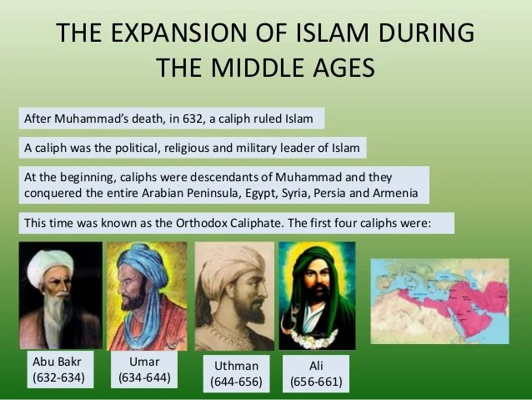

- The Umayyad Caliphate (661-750) Islam was rule by the Umayyad dynasty and capital was in Damascus, Syria.

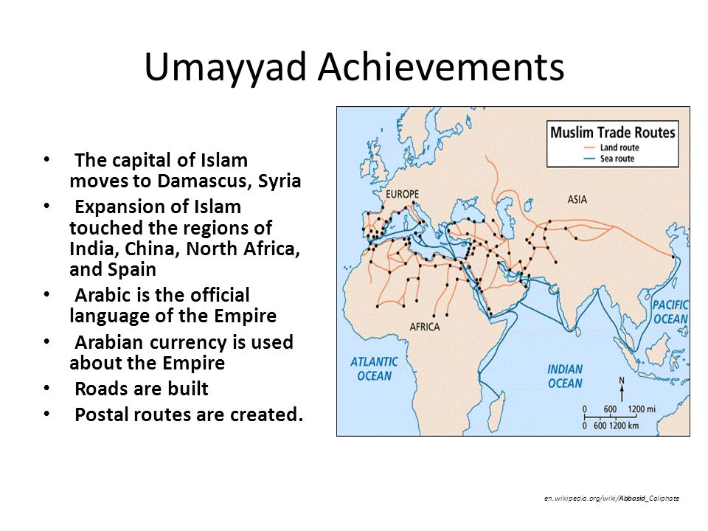
- The Abbasid Caliphate (750 -1258) In 750, The Abbasid family took control of the Islamic empire and moved the capital from Damascus to Baghdad until 1258 when it was conquered by the Mongolians.

ORGANIZATION OF THE EMPIRE
The main authorities in the Islamic society were:
- Caliphs were the highest religious and political authorities.
- The vizier or hayid was the prime minister.
- The Royal treasurers or diwans collected the taxes
- Emirs governed the provinces.
- Judges or qadis applied the laws.

