The most important art in the Islamic world was the architecture. The main characteristics of Islamic architecture are:
- Basic materials such as brick or wood are used but they are covered with other materials like tiles or plaster to give the sensation of richness.
- They used columns and piers to support several types of arches.
- To cover buildings, vaults and domes were used.
- Decoration was very profuse.

TYPES OF ROOFS:
- Muqarna vaults were decorated as if they were stalactites.
- Caliphal ribbed vault contains ribs which do not cross in the center.
- Segmented domes are divided into sections resembling the segments of an orange

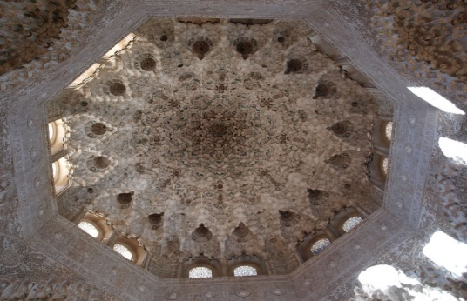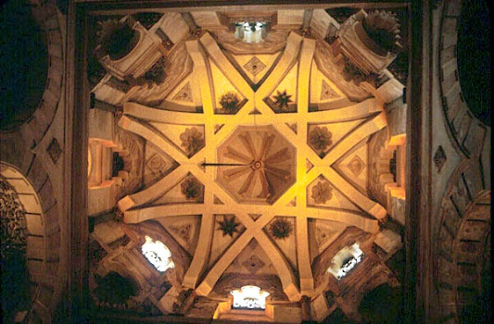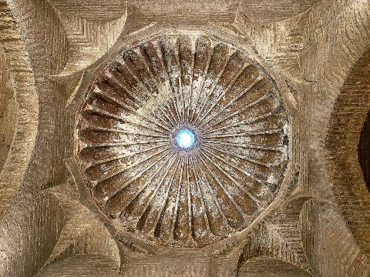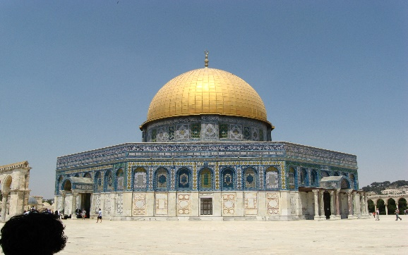
ARCHES:
- Semicircular arch
- Sitlted semicircular arch means that the semicircular arch is slightly lengthened at the bottom.
- Mixtilinear arch made of curves and straight lines.
- Polylobed arch formed with small semicircles.
- Horshoe arches

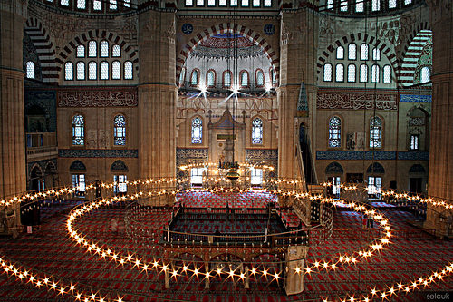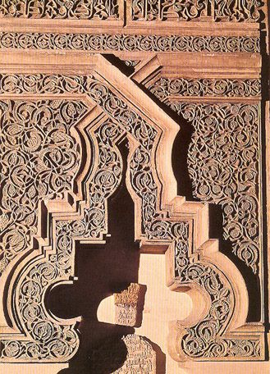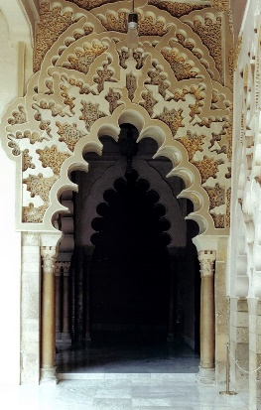
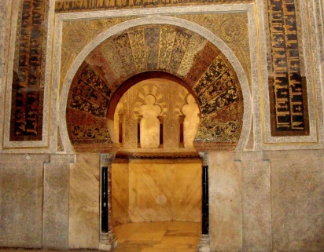

DECORATION
Covered the interiors of the buildings and the main types of decoration were:
- Calligraphic with text from the Koran or poems written in Arabic.
- Simplified and stylized floral and plant designs called arabesque.
- Interlacing or intersecting geometrical patterns and shapes.
