ECOMIC STRUCTURE
This includes economic factors to classify the population. The main divisions are:
- THE POPULATION LEVEL OF ACTIVITY. The different groups are separated according to their position in the economic activity.
- Active population includes working population, the unemployed people and those that are looking for a job.
- Inactive population is made up of children under 16, students,
- retired people, people unable to work and those whose works is not productive.
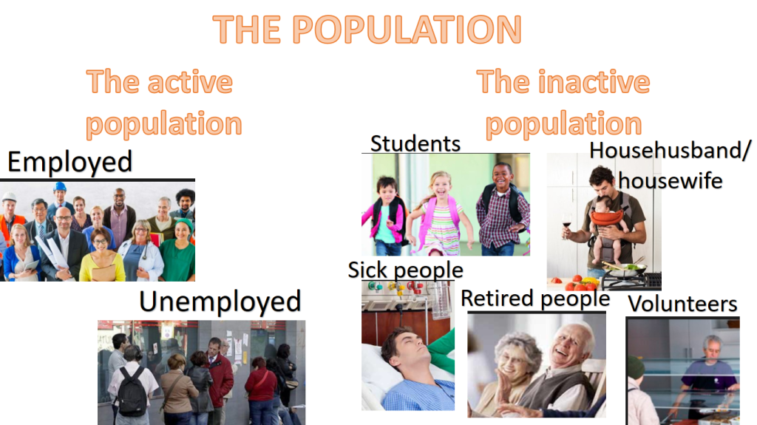

- THE ECONOMIC SECTORS Traditionally the main economic sectors are:
- Primary sector includes workers in agriculture, livestock farming, fishing and forestry.
- Secondary sector involves the transformation of the natural products and refers to those employed in mining, energy production, construction and industry.
- Tertiary sector is based on services such education, health, retail, etc.. This is the largest group of employed people in developed economies.
- Quaternary sector includes knowledge-oriented activities such technical skills, research, and development.
