Population Pyramids Do Now
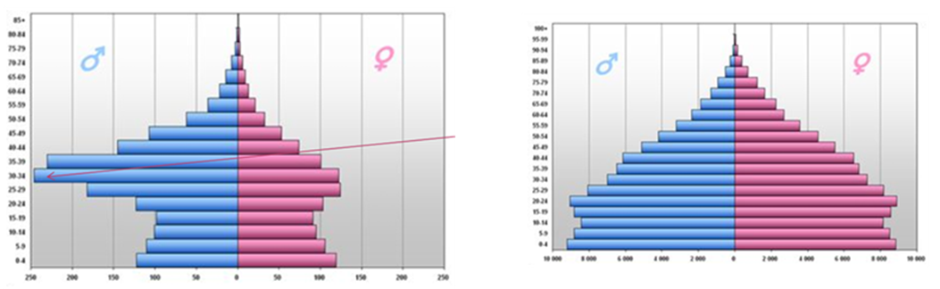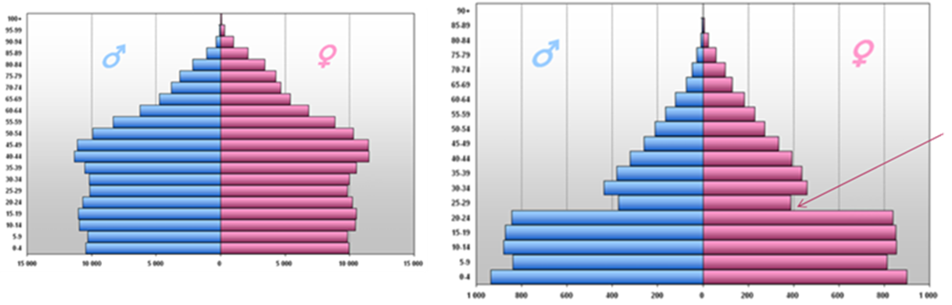
4
3
2
1
Task
- Which population pyramid illustrates a country that practiced gender-selection at one point in its history?
- Which population pyramid illustrate a country that experience devastating war 30 years ago?
- Which population pyramid depicts a country that has good healthcare that is free for all?
- Which population pyramid depicts a country that is generally opposed to the use of contraception?
S&C – in your book
Explain the reasons for your choices using specific facts from the population pyramids.

Super stretch! – in your book
Create a population pyramid that shows a country with an aging population (more elderly than young people).

